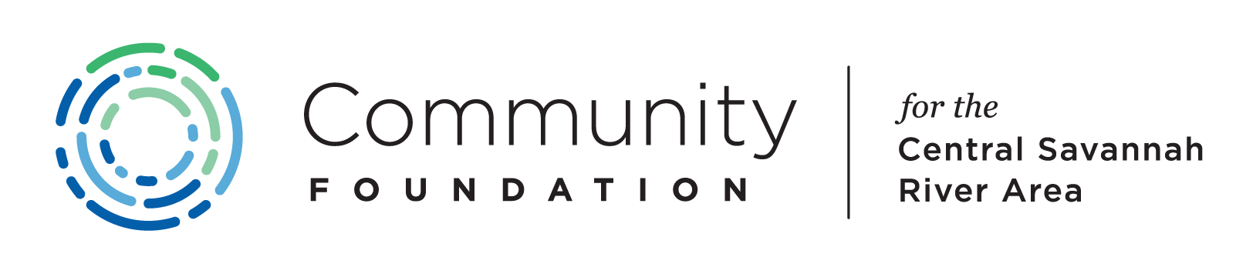

To give away money is an easy matter and in any man’s power. But to decide to whom to give it, and how large and when, for what purpose and how, is neither in every man’s power nor an easy matter.
Aristotle
What is a site visit?
A site visit is an integral part of the grant making process. Panels will see first-hand the operations of the applicant organization. A site visit provides invaluable information that cannot be obtained from a written proposal. Site visits are primarily “information gatherings” to be paired with the organization’s application. It is the general consensus that site visits considerably influence how a panel rates the requests it reviews.
Purpose of the site visit:
- To meet the people behind the proposal.
- To see/assess the facility from which the proposed service(s) will be delivered.
- To engage Board members and staff in a dialogue to address questions/concerns raised in the proposal and information not covered in the proposal.
- To make possible valuable, subjective and objective responses to a program.
- To provide pictures for the words in the written proposal and to help further understand the project and the need being addressed.
- To indicate the seriousness with which a decision is made.
Preparing for the site visit:
Before starting out on a site visit, be sure to:
- Review the grant application thoroughly. Make notes about things that are of concern or are unclear, contradictory, or inaccurate. Take this information with you to the site visit so that any questions may be addressed.

- Panel Chairs will call to set up the appointment. When calling be specific about who should be present for the site visit (board, staff and/or volunteers). Inform the organization’s representatives who the members of your site visit team will be. Briefly explain the goals of the visit and estimate how much time will be required for the visit (usually only one hour).

NOTE: We have advised each organization as to which panel will be reviewing their grant application and will encourage them to be pro-active - to contact the panel chair and schedule a site visit that is convenient for the panel chair.

Conducting the site visit:
In order to be fair to all applicants, it is helpful to use a simple one-page form that all persons making site visits will complete. The Foundation has provided one as a template, but feel free to customize it for your panel. At a minimum, have site visit team members agree beforehand on the general questions to be covered on all site visits. This will allow for objectivity and guarantee consistency in the review process. Also, don’t be afraid to ask tough questions.
Please keep in mind, a site visit does not automatically result in funding. Be sure to clarify this at the start of the visit. Panels should not suggest any expected results to any of their applicants as final decisions are made by The Community Foundation’s Board of Directors after reviewing the panel recommendations.

REMEMBER
An organization may submit a great grant application, but it may be for a mediocre program. On the other hand, an organization my struggle with the application but have a very strong program producing great results. We ask that the panel chair and one or more panel members visit each organization you are asked to review. We encourage everyone on the panel to attend all the site visits if possible.
The Community Foundation extends our most sincere thanks for your part in making these major grant making decisions – decisions that make our community a better place to learn, live, play, and work.

